3R Project to Reduce, Reuse and Recycle successfully launched in Samagipura, Ratnapura

Rainforest Protectors of Sri Lanka volunteers together with Ratnapura UC and PHI’s, successfully launched a 3R (Reduce, Reuse, Recycle) project in Samagipura village, Ratnapura on Saturday November 17. One hundred families were picked up for this initial project with each family receiving four labeled large Polysack bags for collecting Plastics, Paper, Glass and Metal for Recycling. Additionally each family received a Reusable shopping bag to be used instead of plastic grocery bags. The goal of the project is to protect the environment by promoting recycling instead of harmful practices such as dumping, burning and throwing non-biodegradable waste in environmentally sensitive areas.

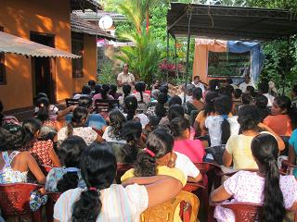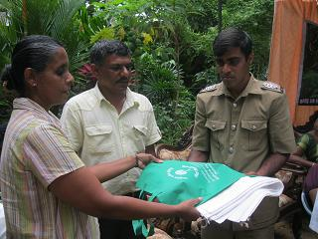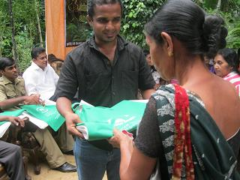

A follow-up will be carried out in December with the intention of expanding the initiative to other villages nearby in the future. Rainforest Protectors of Sri Lanka wishes to thank Nawaloka Group, FLIPIT and PLC Solutions for Sponsoring the project as well as Ratnapura Mayor, Ratnapura UC members Mr. Duminda Koswaththa and Mr. Anura, and Mr. Sajith Dananjaya from Katugasella for the assistance given.

November 17, 2012
Rainforest Protectors of Sri Lanka
http://www.RainforestProtectors.info

